**YEAR 12 PHYSICS, UNIT 4**

#### Modern Physics Test

#### 

**NAME:** ____________________________________ **TOTAL MARKS: /55**

TIME ALLOWED:60 minutes

INSTRUCTIONS:

Write your answers in the spaces provided beneath each question. The value of each question is shown with each question.

Sufficient working should be provided with a complete, logical, clear sequence of reasoning showing how the final answer was arrived at; correct answers which do not show full working will not necessarily be awarded full marks.

When calculating numerical answers, show your working or reasoning clearly. Give final answers to **three significant figures** where applicable using scientific notation and include appropriate units where applicable.

When estimating numerical answers, or reading off a graph, show your working or reasoning clearly. Give final answers to a maximum of **two significant figures** and include appropriate units where applicable.

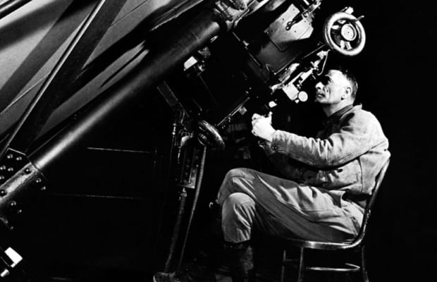

Question 1 [4 marks]

The diagram below schematically illustrates the famous Michelson-Morley Experiment, conducted in an attempt to provide evidence for the existence of ‘luminiferous aether’.

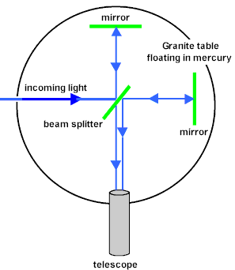

1. Explain what Michelson & Morley expected to observe (in the telescope) and how this would have provided evidence for the existence of aether: [2]

__________________________________________________________________________

__________________________________________________________________________

__________________________________________________________________________

__________________________________________________________________________

1. The notion of aether arose from ideas of classical relativity. If the aether could have been proven to exist, it would have provided an explanation for two problems with classical relativity; what were these problems? [2]

___________________________________________________________________________

___________________________________________________________________________

___________________________________________________________________________

___________________________________________________________________________

**Question 2** [3 marks]

The lowest reported value for the Hubble constant is around 67 km s-1 Mpc-1. Given that 1 parsec (pc) = 3.09 x 1016 m, calculate the age of the universe predicted by this value. Give your answer in years.

Question 3 [5 marks]

a) The diagram left illustrates the repulsion of two electrons. What is the specific particle ‘X’ which is exchanged to carry this electromagnetic repulsive force?

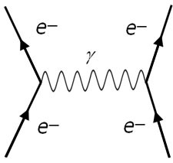

X

‘X’

___________________________________________________________

b) Another boson is responsible for the force which binds quarks together. What is the name of this force and boson?

___________________________________________________________

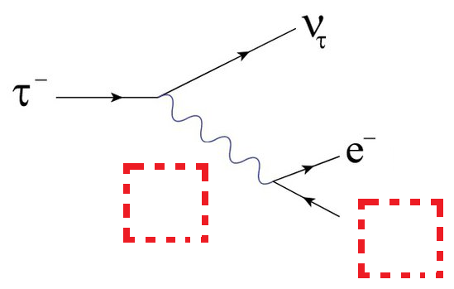

c) The diagram (right) shows tau decay. Identify the missing particles.

Question 4 [3 marks]

For each particle interaction shown below, state in the 'working' section **any and all** conservation law(s) which are violated using the information in the table. If no conservation laws are violated, then write “ALLOWED” in the 'working' section. Please note that, for the interactions shown as diagrams, the ‘time’ axis flows from **bottom to top.** [5]

|  |  |  |
| --- | --- | --- |
| **Name** | **Symbol** | **Baryon #** |
| Proton | p | 1 |
| Neutron | n | 1 |
| Sigma-plus | ∑+ | 1 |
| Sigma-minus | ∑- | 1 |
| Sigma-neutral | ∑0 | 1 |
| Pion-plus | π+ | 0 |

|  |  |
| --- | --- |
| **Diagram** | **Working** |
| **∑+**  ∑- |  |
| Image result for feynman diagram neutron decay  W-  n  p  e |  |
| ∑0 π+ |  |

**Question 5** [7 marks]

The Big Bang theory describes the history of space-time as starting from a small singularity and expanding into our current universe over around 14 billion years.

1. Describe the phenomenon of redshift and briefly explain its role in providing evidence to support the Big Bang theory. [3]

________________________________________________________________________________

________________________________________________________________________________

________________________________________________________________________________

________________________________________________________________________________

________________________________________________________________________________

________________________________________________________________________________

1. The Big Bang theory has led to some intersting postulations, such as the prediction of the existence of ‘dark matter’ and ‘dark energy’. Explain *why* each of these phenomena have been purported to exist. [4]

________________________________________________________________________________

________________________________________________________________________________

________________________________________________________________________________

________________________________________________________________________________

________________________________________________________________________________

________________________________________________________________________________

**Question 6** [2 marks]

State the two postulates of Special Relativity:

________________________________________________________________________________

________________________________________________________________________________

________________________________________________________________________________

________________________________________________________________________________

**Question 7** [9 marks]

Astronaut Gary is floating in space and is surprised to see a Borg Spaceship flying past. He sees it passing at a constant velocity, close to the speed of light. The spacecraft has light 1 at the front and light 2 at the rear. Gary **sees the two lights 1 and 2 illuminate simultaneously** as the ship passes. Hugh is a passenger in the middle of the ship. He also sees the lights.

Given this information, circle the correct statements below for questions a), b) and c).



Gary

Light 1

Light 2



Hugh

motion

1. Gary sees light from 1 *reach Hugh* before light from 2
2. Gary sees light from 2 *reach Hugh* before light from 1
3. Gary sees light from 1 and 2 *reach Hugh* at the same time

Explain your answer

________________________________________________________________________________

________________________________________________________________________________

_____________________________________________________________________________ [2]

1. Hugh sees light from 1 arrive before 2
2. Hugh sees light from 2 arrive before 1
3. Hugh sees both lights arrive at the same time [1]
4. Hugh concludes that the lights flashed simultaneously
5. Hugh concludes that light 1 flashed before light 2
6. Hugh concludes that light 2 flashed before light 1 [1]
7. Hugh and Gary have identical stopwatches set to countdown from one minute. As Hugh passes Gary, both stopwatches commence their countdown. Hugh states that his stopwatch will finish the countdown first but Gary states the opposite. Explain who is correct and why.[2]

______________________________________________________________________________

______________________________________________________________________________

______________________________________________________________________________

______________________________________________________________________________

1. Hugh measures his ship as a square prism of width 10 m and length 80 m. Gary observes the spaceship as a perfect cube. Calculate the ship’s velocity relative to Gary. [3]

Question 8 [4 marks]

The 'Millennium Falcon' (shown left, below) and the 'USS-Enterprise' (shown right) are travelling in exactly opposite directions (they are from completely different franchises after all!), as viewed from a third party on some small planet in the Delta Quadrant. The observer measures their speeds as 0.7c (Falcon) and 0.85c (Enterprise). Find:

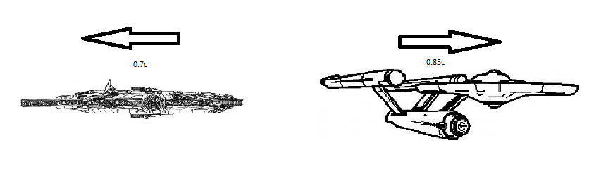

1. The velocity of the Falcon as measured by the Enterprise. [3]
2. The velocity of the Enterprise as measured by the Falcon.[1]

**Question 9** [5 marks]

In the Standard Model of particle physics, hadrons are composed of combinations of quarks or antiquarks. Hadrons are further divided into two families: Baryons and mesons.

(a) Describe the difference in quark composition between a baryon and a meson. [2]

(b) Below is a list of the 6 different quarks that make up hadrons.

|  |  |  |  |  |  |  |  |
| --- | --- | --- | --- | --- | --- | --- | --- |
| **NAME** | **SYMBOL** | **Charge (Q)** | **Baryon Number (B)** | **Strangeness (S)** | **Charm**  **(c)** | **Bottomness (b)** | **Topness**  **(t)** |
| *Up* | U | e |  | 0 | 0 | 0 | 0 |
| *Down* | D | e |  | 0 | 0 | 0 | 0 |
| *Strange* | S | e |  | -1 | 0 | 0 | 0 |
| *Charmed* | C | e |  | 0 | +1 | 0 | 0 |
| *Bottom* | b | e |  | 0 | 0 | -1 | 0 |
| *Top* | t | e |  | 0 | 0 | 0 | +1 |

State the composition of the following hadrons: [3]

(i) the neutron, with Q = 0, B = +1, and S = c = b = t = 0

(ii) the charmed Xi (Ξ+c) baryon, with Q = +1, B = +1, S = -1, c = +1 and b = t = 0

(iii) the Kaon (K+) meson, with Q = +1, B = 0, S = +1 and c = b = t = 0

Question 10 [7 marks]

A sample of ionised gas inside a particle accelerator is observed to have a proper mass of

2.5 x 10-10 kg. It is accelerated to 0.99c. Find the following:

1. Relativistic mass of the sample: [2]
2. Relativistic momentum of the sample: [1]
3. Kinetic energy of the sample: [2]
4. The sample enters a magnetic field. If the radius of its path in the magnetic field is 80 m and the magnetic field is 2.5 T, calculate the charge of the ionised sample [2]

Question 11 [6 marks]

Spectral analysis sunlight shows the presence of Sodium. The ‘sodium-D’ emission line occurs at a wavelength of 589 nm when measured on Earth.

Top of the Sun

*Wavelengths of 589 nm Sodium-D line emission from the Sun, as observed from Earth*

589.0037 nm

588.9963 nm

The shift of this wavelength when viewed at the equator on either side of the Sun allows the surface speed and thus rotational period to be calculated.

1. With reference to the above diagram state the direction of rotation of the Sun when viewed from above. Circle one of the options below and briefly explain your response. [2]

**Clockwise Anti-clockwise Impossible to determine**

Explain briefly

______________________________________________________________________________

______________________________________________________________________________

______________________________________________________________________________

1. The Doppler shifted wavelength of light is given by the equation:

$$\frac{∆λ}{λ}= \frac{v}{c}$$

Where Δλ = difference of emitted wavelength compared to laboratory wavelength, λ = laboratory wavelength, and v is the velocity of the light source. Use this equation, along with data in the diagram above and in your data sheet, to calculate the **period of rotation** of the Sun, in days. [4]

**END OF TEST**